39.59: a)
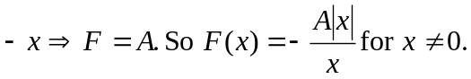
b) From Problem 39.58, 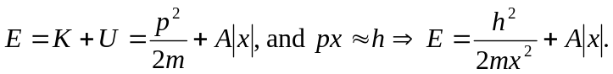
For 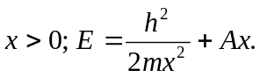 The minimum energy occurs when 